

**American International University- Bangladesh**

**CSC 2209: Object Oriented Programming 1 (JAVA)**

**CO1 Evaluation**

**Project Summary Report**

**Fall 19-20**

**Group ID: C06**

**Project Title: Student Attendance Management System**

|  |  |
| --- | --- |
| Student Name | Student Id |
| TOMAL, MD HASIBUR RAHMAN | **17-35018-2** |
| SIDDIKA,AYESHA | **17-35220-2** |
|  |  |
|  |  |

**Introduction:**

I want to make simple desktop application for the faculties so that they can take the attendance of students in every class easily. By this an admin also can manage faculties.

**User Category:**

There are two types of Users here. They are:

* Admin
* Faculty

**Feature List:**

In this project the Admin has the following features:

* Manage the faculty list
* Add Faculty
* Add Admin
* Update faculty and admin information
* Change own password

In this project the Faculty has the following features:

* Manage the student list
* Take attendance
* Add student
* Update student information
* Change own password

**Frame Description:**

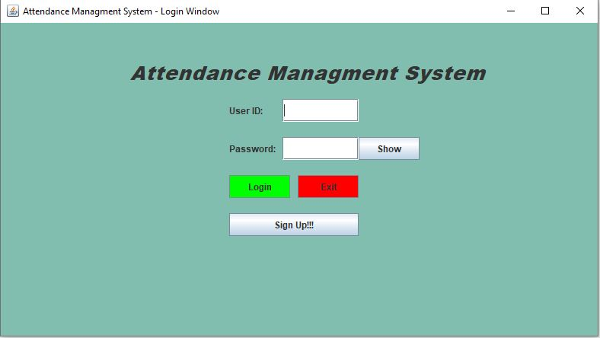

Frame: Login Frame

**Login Frame:** Login frame is the first frame of the whole system. Admin and Faculty both login from here.

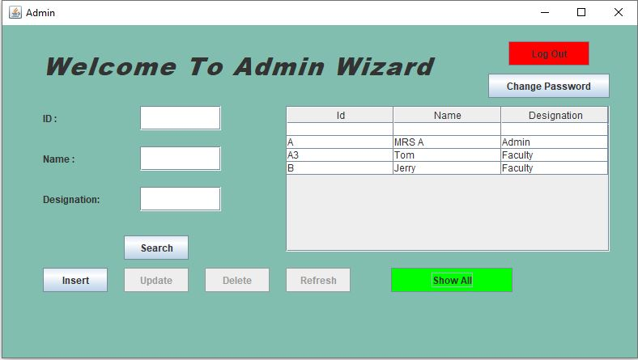

*Frame: Admin Frame*

**Admin Frame:** After Login admin can add, update, and delete any employee’s information from this frame.

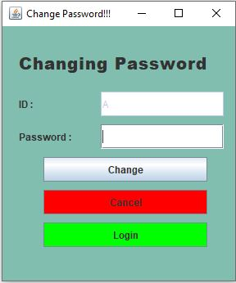

*Frame: Password changing Frame*

**Password Changing Frame:** This frame is for changing password for both faculty and admin.

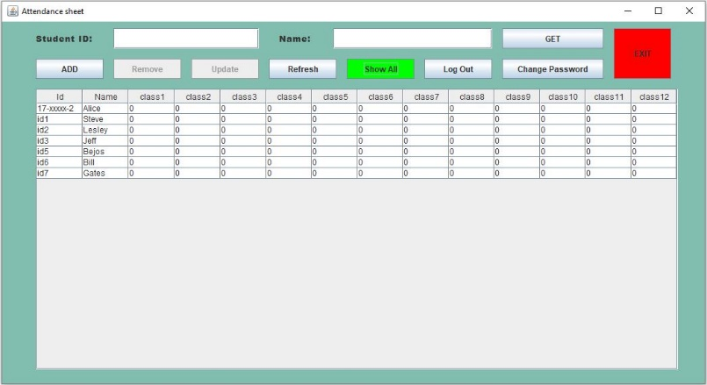

*Frame: Attendance sheet*

**Attendance Sheet:** Attendance sheet is for Faculties, who can add, update, and delete any student’s information from here.

**Database Table Description:**

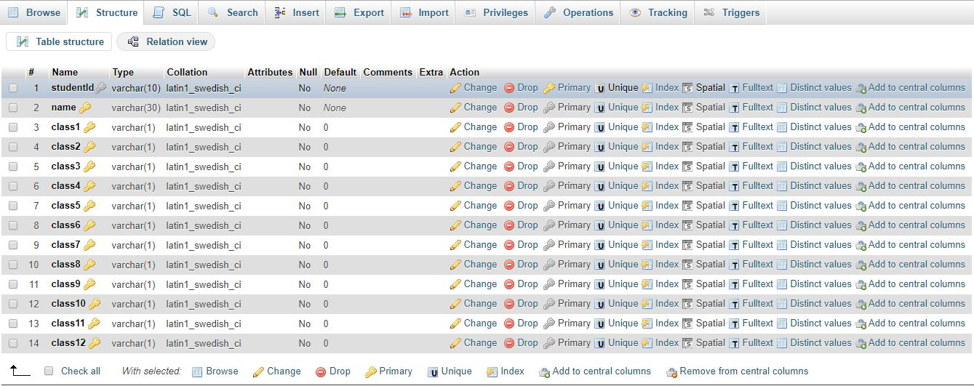

***Table: AttendanceSheet***

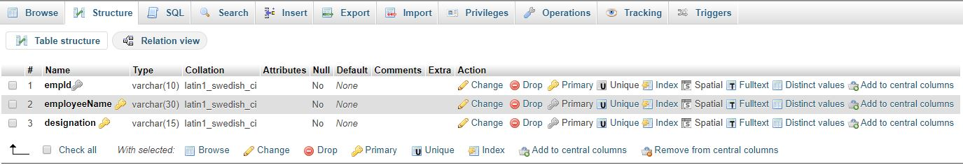

***Table: Employees***

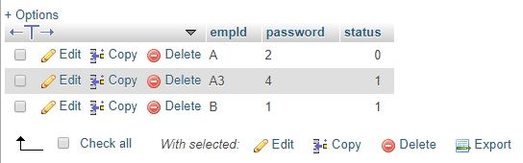

***Table: Login***

**Class Diagram:**

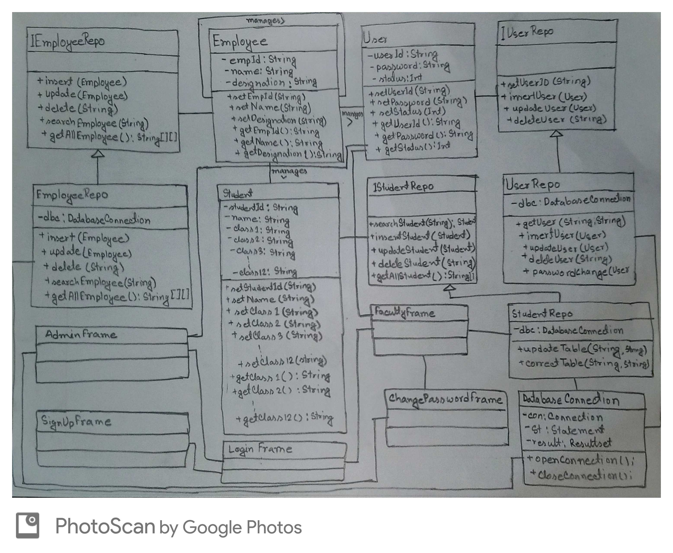

**Tools Used:**

To develop this project we have used the following:

* Notepad++ (v7.8.2)
* Xampp (v3.2.2)
* JDK 8
* SQL

**OOP and Java Concepts Used:**

* Abstraction :
* Encapsulation: It’s the protection barrier that keeps the data safe.
* Inheritance: It lets programmer to share data and methods in other classes.
* Polymorphism: It lets objects to act different in different situations.
* Association: This defines the relationship between objects

**Impact of this Project:**

As this a simple project for taking attendances, it can reduce the uses of papers in some situations. By which any personnel can by beneficial partially.

People will be beneficial by saving their time and having the attendance system more easier. Also institutions will be beneficial if they use this system for managing their employees.

**Limitations and Possible Future Improvements:**

This system cannot calculate the marks of students. Also this system only can record attendance of 12 classes.

In future there could be a feature for calculating individual marks by after taking the attendance. Also this system can be updated as this can add classes as faculty wants. Semester also not differentiated, this can be added.